- Explain de-Broglie hypothesis and derive the expression for matter wavelength. Discuss its significance.
- What are matter waves? Explain the characteristics of de Broglie waves.
- Define the wave function and state its properties.
- Derive the de Broglie wavelength of a free particle in terms kinetic energy and for an electron accelerated through a potential difference V.
- The trotting speed of an elephant is 10 m/s. Calculate the associated de Broglie. wavelength. (Mass of the elephant = 1000 kg).
- Compare the energy of a photon with that of a neutron when both are associated with a de Broglie wavelength of 1 Å. Given mass of neutron is 1.674 x 10⁻²⁷ kg . (5 Marks)
- Analyze the variation of the de Broglie wavelength of an electron when the accelerating potential increases from 100 V to 400 V. Calculate the respective wavelengths and explain the physical significance of your observation.
- Analyze the momentum of an electron and the de Broglie wavelength associated with it if its kinetic energy is 1.5 KeV.
- Write and explain the properties of Dirac notation.

- 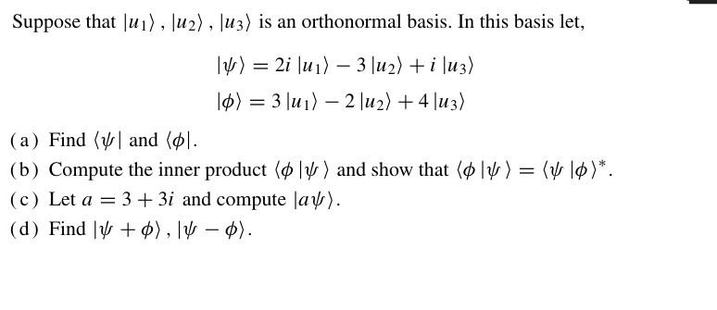
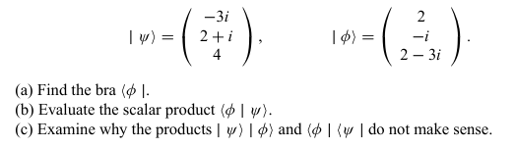
- Write the three Pauli spin matrices, Explain the properties of Pauli metrics .
- Explain the concept of a qubit and its properties. Discuss the technological limitations that have slowed down Moore’s Law.
- Write the differences between classical and quantum computers.
- Analyze how the parameters θ and ϕ determine the position of a qubit state on the Bloch sphere. Explain their effect on measurement probabilities.
- 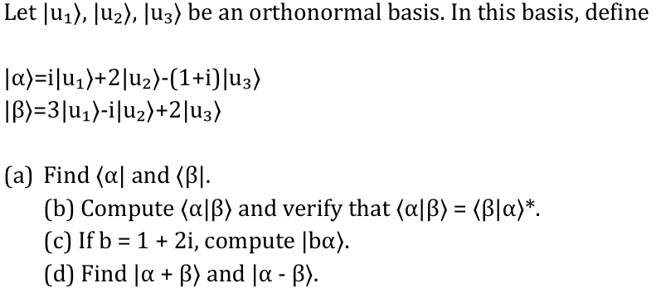
- Explain in detail the Pauli-X, Pauli-Y, and Pauli-Z gates with their matrix representation, symbolic form, out product form and truth table. Derive their effect on basis states ∣0⟩ , ∣1⟩ and 𝛼∣0⟩+𝛽∣1⟩.
- Explain the working of multiple-qubit gates Swap gate, and Controlled-Z with their matrix representation, symbolic form, out product form and truth table.
- Write short note on Phase (S) Gate and T Gate.
- 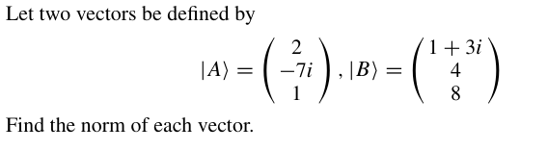
- 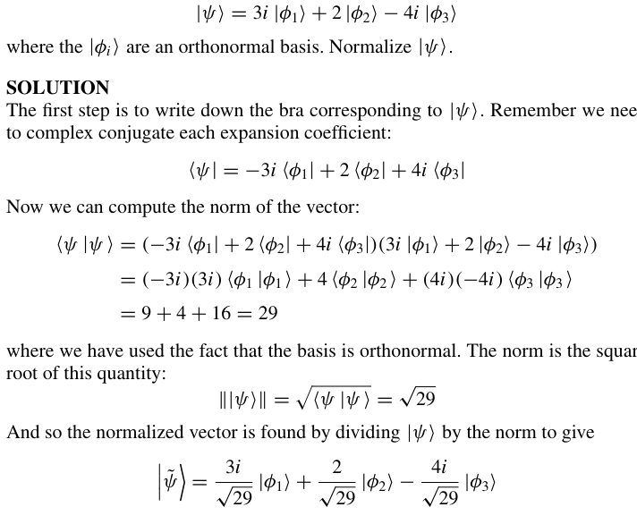
- Analyze the operation of the Toffoli (CCNOT) gate for different input combinations.
- Explain the working of multiple-qubit gates CNOT, and Controlled-Z with their matrix representation, symbolic form, outer product and truth table.
- Define identity operator. Show the determination of I|0⟩ and I|1⟩.

